“The KZN Provincial Infrastructure Coordination Workgroup in collaboration with the Provincial Planning Commission has been tasked to develop the KZN Provincial Infrastructure Master Plan. The objective of this Master Plan is to ensure that strategic infrastructure is developed to support the successful implementation of the PGDP. The Master Plan will provide a technical platform for the spatial alignment, time-line programming and budgetary alignment of the respective infrastructure components. This will promote effective, efficient and economical provision of both economic (productive) and social (redistributive) infrastructure services. Key outcomes of this will be:

- Identification of critical infrastructure gaps and the quantification of resource constraints required to bridge these gaps
- Prioritised projects with both long term planning as well as approved short term MTEF budgets.

The Master Plan will be aligned with and respond essentially to the Strategic Integrated Projects (SIPs) of the Presidential Infrastructure Coordinating Commission and the KZN Provincial Growth and Development Plan (PGDP) as well as other pertinent planning processes.” (Source: PGDP)

In terms of the Provincial Growth and Development Plan, Catalytic projects are large-scale development projects, which directly stimulate and leverage much higher levels of development and initiation of further projects. Effective tracking and monitoring to compliment implementing agents responsibilities are seen are important and this project registration and application process are viewed as a one means in support thereof.

A Catalytic Project can be further sub-categorised as follows:

Major Need: This applies to projects that are meant to address wide-scale regional needs.
Major Enabler: This applies to projects that will unlock downstream infrastructure services.
Game Changers: This applies to projects that will structurally change the economy.

Examples:
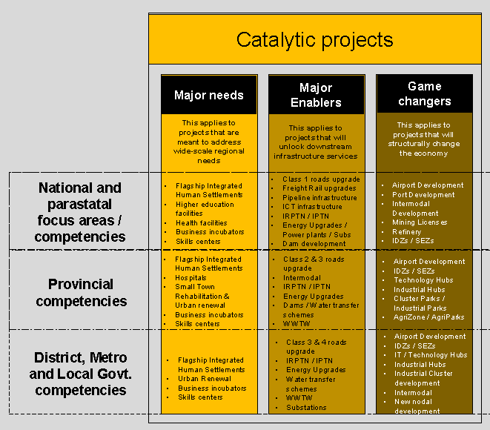

The criteria to assist with Catalytic Project assessment are provided below. Please complete each of the sections and return this questionnaire together with any additional supporting documentation as may be applicable.

Please return your submission or any query you may have per registered mail or email to:

PROVINCIAL PLANNING COMMISSION SECRETARIAT

Moses Mabhida Building
300 Langalibalele Street
Pietermaritzburg
KwaZulu-Natal
3200
TEL: 033 341 4765
dawn.dorning@kznpremier.gov.za
and
roxanne.wilmot@kznpremier.gov.za

PLEASE CONTINUE TO THE NEXT PAGE TO COMPLETE THE QUESTIONNAIRE.

SECTION A: PROJECT AND PROJECT OWNER DETAILS

PROJECT OWNER / DEPARTMENT / SOC / COMPANY NAME:
Click here to enter text.
PROJECT NAME
Click here to enter text.
SHORT DESCRIPTION OF PROJECT
Click here to enter text.
PHYSICAL ADDRESS:
Click here to enter text.
Click here to enter text.
Click here to enter text.
Click here to enter text.
Click here to enter text.

POSTAL CODE: | Click here to enter text.
CONTACT PERSON NAME: | Click here to enter text.
CONTACT PERSON EMAIL: | Click here to enter text.
CONTACT PERSON MOBILE: | Click here to enter text.
CONTACT PERSON LANDLINE: | Click here to enter text.
DATE COMPLETED: | Click here to enter a date.
COMPLETED BY: | Click here to enter text.

SECTION B: MOTIVATION

- The extent to which the project can support the achievement of at least four Strategic Goals contained in the PROVINCIAL GROWTH AND DEVELOPMENT PLAN (pgdp)

1.1 GOAL 1: INCLUSIVE ECONOMIC GROWTH ☐
WRITTEN MOTIVATION AND/OR SUPPORTING DOCUMENT PROVIDED
Click here to enter text.

1.2 GOAL 2: HUMAN RESOURCE DEVELOPMENT ☐

WRITTEN MOTIVATION AND/OR SUPPORTING DOCUMENT PROVIDED
Click here to enter text.

1.3 GOAL 3: HUMAN AND COMMUNITY DEVELOPMENT ☐

WRITTEN MOTIVATION AND/OR SUPPORTING DOCUMENT PROVIDED
Click here to enter text.

1.4 GOAL 4: STRATEGIC INFRASTRUCTURE ☐

WRITTEN MOTIVATION AND/OR SUPPORTING DOCUMENT PROVIDED
Click here to enter text.

1.5 GOAL 5: ENVIRONMENTAL SUSTAINABILITY ☐

WRITTEN MOTIVATION AND/OR SUPPORTING DOCUMENT PROVIDED
Click here to enter text.

1.6 GOAL 6: GOVERNANCE AND POLICY ☐

WRITTEN MOTIVATION AND/OR SUPPORTING DOCUMENT PROVIDED
Click here to enter text.

1.7 GOAL 7: SPATIAL EQUITY ☐

WRITTEN MOTIVATION AND/OR SUPPORTING DOCUMENT PROVIDED
Click here to enter text.

- technical data

2.1 The magnitude of investment being attracted to the Province.

The Total Investment Value is R Click here to enter text.

The percentage of the Total Investment Value already secured (%):Click here to enter text.

2.2 potential of the project to stimulate both upstream and downstream opportunities in the value chain

WRITTEN MOTIVATION AND/OR SUPPORTING DOCUMENT PROVIDED
Click here to enter text.

2.3 The scope nature and extent of employment creation opportunities.

WRITTEN MOTIVATION AND/OR SUPPORTING DOCUMENT PROVIDED
Click here to enter text.

2.4 The scale and scope for meaningful black economic empowerment.

WRITTEN MOTIVATION AND/OR SUPPORTING DOCUMENT PROVIDED
Click here to enter text.

2.5 PROJECTED CONSTRUCTION DATES

PLANNED CONSTRUCTION COMMENCEMENT | PLANNED CONSTRUCTION COMPLETION
Click here to enter a date. | Click here to enter a date.

2.6 PROJECT LOCATION: LATITUDE-LONGITUDE

LATITUDE | LONGITUDE
Click here to enter text. | Click here to enter text.

2.7 PROJECT PHOTO GALLERY (pLEASE INSERT ANY IMAGES FOR YOUR PROJECT)

IMAGE 1 | IMAGE 2

